

The Friday Flyer
John Bunyan Primary School & Nursery

Thursday 23rd May 2024
Reminder: Non-Pupil Day, Friday 24th May
Half-Term Holiday Monday 27th – Friday 31st May
Return to School: Monday 3rd June
School Dinners
SUMMER 2024 MENU
Week commencing Monday 3rd June – Week 1
Week commencing Monday 10th June – Week 2
Week commencing Monday 17th June – Week 3

Copies of the school dinner menu are always available to view on our website www.johnbunyan.co.uk and paper copies are available from the school office.

.

Tesco Stronger Starts project
Thank you to everyone who popped their blue token into the voting container to support our application for a grant from Tesco. We were awarded £500 towards our sensory garden.

Year 6 theatre show
Our Year 6 pupils will be watching a touring show by the Mercury Theatre, as part of Essex Year of Numbers. It is called ‘Fixing Numberdom’ and our year 6 children were involved in helping the practitioners develop the show earlier in the year.

Ofsted
Following our Ofsted inspection earlier this year, when we were judged to be a Good School, the full report is now available to view on the school website www.johnbunyan.co.uk by selecting the “Our School” tab, followed by “Ofsted”.
Trips and Activities now booking
- Permission to walk home alone (Years 5&6)
- Year 6 residential trip 2023
- Home School Agreements
- Imperial War Museum trip for Year 6
- Young Voices


Trips and Activities now booking
- Permission to walk home alone (Years 5&6)
- Year 6 residential trip 2023
- Home School Agreements
- Imperial War Museum trip for Year 6
- Young Voices

SEND Parents
Support for parents and carers with children of any age with Special Educational Needs and Disabilities:
Drop in coffee afternoon and chat in school
1.45pm – 2.45pm on
Monday 17th October
Monday 21st November
Monday 19th December
Come along for an informal chat

SEND Parents
Support for parents and carers with children of any age with Special Educational Needs and Disabilities:
Drop in coffee afternoon and chat in school
1.45pm – 2.45pm on
Monday 17th October
Monday 21st November
Monday 19th December
Come along for an informal chat

SEND Parents
Support for parents and carers with children of any age with Special Educational Needs and Disabilities:
Drop in coffee afternoon and chat in school
1.45pm – 2.45pm on
Monday 17th October
Monday 21st November
Monday 19th December
Come along for an informal chat

SEND Parents
Support for parents and carers with children of any age with Special Educational Needs and Disabilities:
Drop in coffee afternoon and chat in school
1.45pm – 2.45pm on
Monday 17th October
Monday 21st November
Monday 19th December
Come along for an informal chat

Sports Days
We would like to invite parents and carers into school on the following days to watch their children taking part in sports days:
Reception Year: Monday 8th July, 9.30am–10.30am
Years 1 and 2: Friday 5th July, 1.30pm–3.00pm
Years 3 and 4: Monday 1st July 1.30pm–3.00pm
Years 5 and 6: Wed 10th July, 9.15am-10.45am
Nursery parents will be notified separately when the Nursery sports and games day will be held.
World Music Day
World Music Day is Friday 21st June. We are currently learning the song “Lean on Me” and we will be joining schools all across the country to sing this at 2.30pm on the day.

TT Rockstars Day
Wednesday 5th June is our Times Tables Rock Stars and Number Day. Years 2–6, come to school dressed as your favourite rock star!
Nursery, Reception Year and Year 1 can dress up as a number or anything to do with numbers. It will be a day filled with lots of maths fun!

Year 6 transition days
Alec Hunter Academy – 27th and 28th June
Tabor Academy – 28th June
Notley High School – 27th and 28th June
Honywood School – 27th and 28th June
Forest Hall School – 27th June
Chelmsford High School for Girls – 26th June
Thurstable School – 27th June

Pupils should go straight to their senior school on those days, and not come to John Bunyan first.

Headlice
Please remember to check your child’s hair regularly and treat the whole family if you see any signs of headlice.
We would encourage pupils with long hair to wear their hair tied back in school.

Trips and Activities now booking
- Permission to walk home alone (Years 5&6)
- Year 6 trip to Frinton
- Home School Agreements
- Book bags, PE bags, swim hats
- Snack
- Current Year 5 residential trip
- Sports events
- Year 4 trip to Abberton

SEND Parents
Support for parents and carers with children of any age with Special Educational Needs and Disabilities:
Drop in coffee afternoon and chat in school
1.45pm – 2.45pm on
Monday 17th June 2024
Monday 15th July 2024
Come along for an informal chat


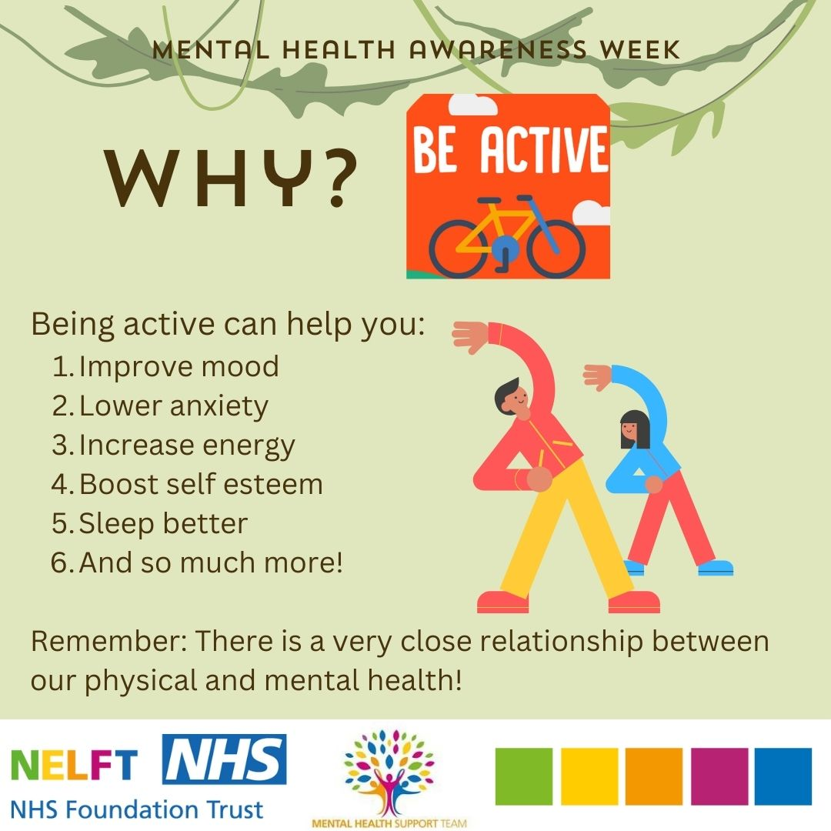
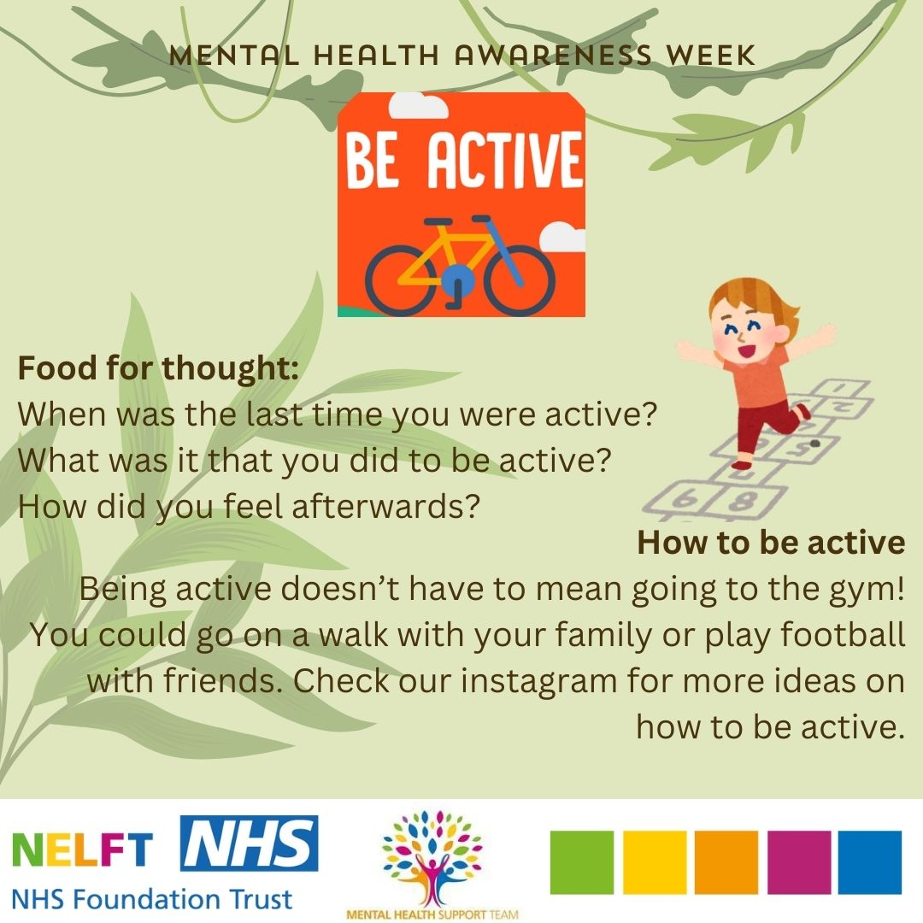

Diary Dates
Friday 24th May – Non-Pupil Day for staff training
Week commencing Monday 27th May – Half Term holiday
Monday 3rd June – Back to School
Tuesday 4th June – Year 6 theatre show in school
Wednesday 5th June – Times Tables Rockstars Day
Friday 7th June – Hazels and Junipers to visit Braintree Library
Monday 10th June – Beeches and Rowans to visit Braintree Library
Friday 14th June – Yews and Poplars to visit Braintree Library
Monday 17th June – Year 4 trip to Abberton
Friday 21st June – World Music Day, celebrations in school
Monday 1st July – Years 3 and 4 Sports Day, 1.30pm – 3.00pm
Friday 5th July – Years 1 and 2 Sports Day, 1.30pm – 3.00pm
Monday 8th July – Reception Year Sports Day, 9.30am – 10.30am
Tuesday 9th July – Open afternoon for parents 3.30pm – 5.00pm (details to follow)
Wednesday 10th July Years 5 and 6 Sports Day, 9.15am – 10.45am
Wednesday 17th July – Year 2 end of year celebration for parents – further details to follow (daytime)
Wednesday 17th July – Year 6 end of year celebration for parents (evening event)
Friday 19th July – Last day of term, finish at normal time

 | Term Dates for 2023-2024 Academic Year
Summer Term: | Monday 15th April 2024 – Friday 19th July 2024  Half Term Holiday Monday 27th May to Friday 31st May  Non-Pupil Days: Friday 24th May, Monday 22nd July and Tuesday 23rd July  Bank Holiday: Monday 6th May

Attendance Matters

At John Bunyan we value good attendance and punctuality.

Leave of Absence
The school is not permitted to grant leave of absence during term time, unless there are exceptional circumstances. Evidence of exceptional circumstances needs to be provided alongside a completed leave of absence form. Forms are available from the School Office. If you have any queries, please ask the School Office.

If an absence request is not authorised and the holiday is taken, the Local Authority can issue a penalty notice.

Be Punctual
We expect pupils to be in school before the gates close, ready to start learning. If pupils are on time they will be calm and ready to begin learning. They will not miss out on the vital introduction to a lesson or feel anxious about walking into a classroom once the lesson has started.

Let us know
We do understand that children become ill. If that is the case, please remember to phone the school by 9.30am on the first day of illness.
Absence Line: 01376 321814, option 1

Illness:
Children should not be in school:
- For 48 hours after vomiting or diarrhoea
- If they have anything contagious. Your doctor or the school will be able to advise you on when they should return.
- Until you have discussed any broken bones or fractures with the school
If you are not sure, please speak to the school.

Please think carefully before keeping your child at home

90% ATTENDANCE = ½ DAY MISSED EVERY WEEK.
1 school year at 90% = 4 WHOLE WEEKS OF LESSONS MISSED!
Learning and achievement will be severely affected.

Attendance
Attendance is important
Together we can achieve the best for each child
There is advice and support for parent/carers
Establishing good habits from the start
Not being in school affects life opportunities
Discuss with your child what goes on in school
Arriving late can be disruptive
Notify the school when your child is absent
Celebrate good attendance
EVERY DAY COUNTS

Above all we want your child to be happy and successful at school and we believe that
only by working in partnership with you, will this be possible.

