

The Friday Flyer
John Bunyan Primary School & Nursery

Friday 10th May 2024
Reminder
Non-Pupil Day, Friday 24th May
Half Term Holiday Monday 27th – Friday 31st May
School Dinners
SUMMER 2024 MENU
Week commencing Monday 13th May – Week 2
Week commencing Monday 20th May – Week 3

Copies of the school dinner menu are always available to view on our website www.johnbunyan.co.uk and paper copies are available from the school office.

.

Essex ActivAte May half term activities
Essex ActivAte’s half term programme welcomes school aged children (4-16 years) who are eligible, to book onto activity clubs and enjoy physical activity, enrichment sessions and food education. Please see the attached flyer to find our more and see if your child is eligible.

Year 6
Year 6 SATs will take place during the week commencing Monday 13th May. SATs breakfast will be served each day, free of charge, to all Year 6 pupils at 8.30am in Mrs Bower’s classroom.

PTFA Events
Years 1 and 2 cinema evening
Wednesday 15th May, 4.00pm – 5.30pm
Years 5 and 6 disco
Wednesday 22nd May, 4.00pm – 5.30pm
Years 3 and 4 disco
Thursday 23rd May, 4.00pm – 5.30pm
There will be no after school clubs on those days

Trips and Activities now booking
- Permission to walk home alone (Years 5&6)
- Year 6 residential trip 2023
- Home School Agreements
- Imperial War Museum trip for Year 6
- Young Voices


Trips and Activities now booking
- Permission to walk home alone (Years 5&6)
- Year 6 residential trip 2023
- Home School Agreements
- Imperial War Museum trip for Year 6
- Young Voices

SEND Parents
Support for parents and carers with children of any age with Special Educational Needs and Disabilities:
Drop in coffee afternoon and chat in school
1.45pm – 2.45pm on
Monday 17th October
Monday 21st November
Monday 19th December
Come along for an informal chat

SEND Parents
Support for parents and carers with children of any age with Special Educational Needs and Disabilities:
Drop in coffee afternoon and chat in school
1.45pm – 2.45pm on
Monday 17th October
Monday 21st November
Monday 19th December
Come along for an informal chat

SEND Parents
Support for parents and carers with children of any age with Special Educational Needs and Disabilities:
Drop in coffee afternoon and chat in school
1.45pm – 2.45pm on
Monday 17th October
Monday 21st November
Monday 19th December
Come along for an informal chat

SEND Parents
Support for parents and carers with children of any age with Special Educational Needs and Disabilities:
Drop in coffee afternoon and chat in school
1.45pm – 2.45pm on
Monday 17th October
Monday 21st November
Monday 19th December
Come along for an informal chat


Essex libraries now have a great range of new games available to play, either at home or in the library! All with a maths and numbers theme, these games will help children improve their skills around counting, times tables, handling money, and more!
Become a wizard, play with the number bears or pop to the shops, these new board games have a range of fun themes. You can stay and play in the library or borrow the games to play at home.
Please see the link below for further details.
New family maths games! | News | Essex Library Service

Term Dates 2024-25
Next year’s term dates are available to view on the school website www.johnbunyan.co.uk under the “Parents” tab.

TT Rockstars Day
Wednesday 5th June is our Times Tables Rock Stars and Number Day. Years 2–6, come to school dressed as your favourite rock star!
Nursery, Reception Year and Year 1 can dress up as a number or anything to do with numbers. It will be a day filled with lots of maths fun!

Trips and Activities now booking
- Year 3 trip to Danbury Country Park
- Year 6 leavers hoodies
- Permission to walk home alone (Years 5&6)
- Year 6 trip to Frinton
- Home School Agreements
- Book bags, PE bags, swim hats
- Snack
- Current Year 5 residential trip
- Year 4 trip to Abberton
- Sports events

Year 6 Leavers Hoodies
Year 6 leavers hoodies are now available to order via ParentPay. The hoodies come in a range of colours and sizes – we have sample hoodies in the school office if pupils would like to try one on for size. Please remember to state size and colour required when placing your order. Orders must be received via ParentPay by Monday 20th May. No orders can be accepted after this date. The hoodies will be delivered to school shortly before the end of term. If you have any queries, please contact the school office.

SEND Parents
Support for parents and carers with children of any age with Special Educational Needs and Disabilities:
Drop in coffee afternoon and chat in school
1.45pm – 2.45pm on
Monday 17th June 2024
Monday 15th July 2024
Come along for an informal chat

Sports Days
We would like to invite parents and carers into school on the following days to watch their children taking part in sports days:
Reception Year: Monday 8th July, 9.30am–10.30am
Years 1 and 2: Friday 5th July, 1.30pm–3.00pm
Years 3 and 4: Monday 1st July 1.30pm–3.00pm
Years 5 and 6: Wednesday 10th July, 9.15am-10.45am
Nursery parents will be notified separately when the Nursery sports and games day will be held.

Diary Dates
Week commencing Monday 13th May – Year 6 SATS week
Wednesday 15th May – PTFA cinema evening for Years 1 and 2
Thursday 16th May – Year 3 trip to Danbury Country Park
Wednesday 22nd May – PTFA disco for Years 5 and 6
Thursday 23rd May – PTFA disco for Years 3 and 4
Friday 24th May – Non-Pupil Day for staff training
Week commencing Monday 27th May – Half Term holiday
Monday 3rd June – Back to School
Monday 17th June – Year 4 trip to Abberton
Monday 1st July – Years 3 and 4 Sports Day, 1.30pm – 3.00pm
Friday 5th July – Years 1 and 2 Sports Day, 1.30pm – 3.00pm
Monday 8th July – Reception Year Sports Day, 9.30am – 10.30am
Wednesday 10th July Years 5 and 6 Sports Day, 9.15am – 10.45am
 | Term Dates for 2023-2024 Academic Year
Summer Term: | Monday 15th April 2024 – Friday 19th July 2024  Half Term Holiday Monday 27th May to Friday 31st May  Non-Pupil Days: Friday 24th May, Monday 22nd July and Tuesday 23rd July  Bank Holiday: Monday 6th May

Mad Science Day
We had a wonderful Science Day last week, with experiments and exploring taking place around school all day. Well done to the winners of the Best Dressed Mad Scientist competition. The standard was high, with so many wonderful outfits.
Reception: Emma Year 1: Rafe Year 2: Richard
Year 3: Leksii-Rae Year 4: Evaine Year 5: Dennis Year 6: Vincent
Here is a selection of our scientists at work:
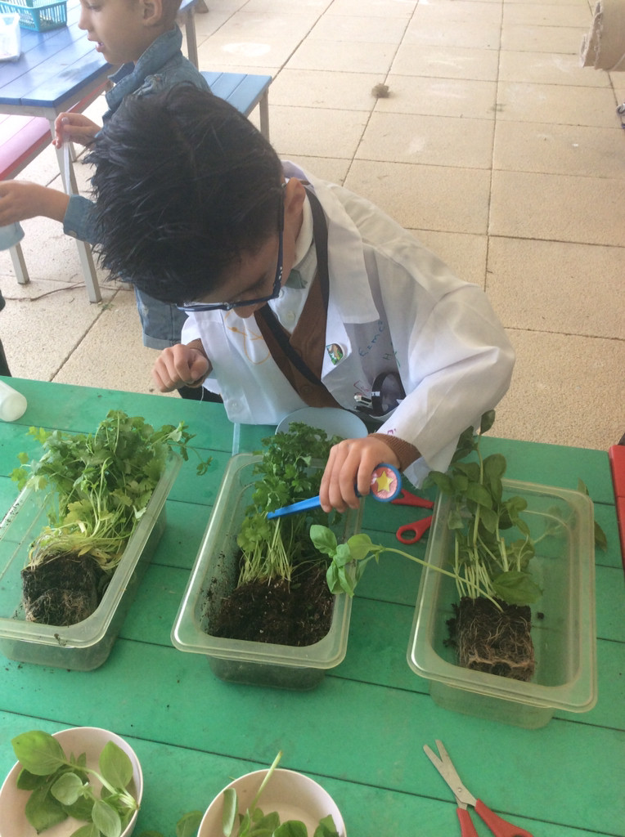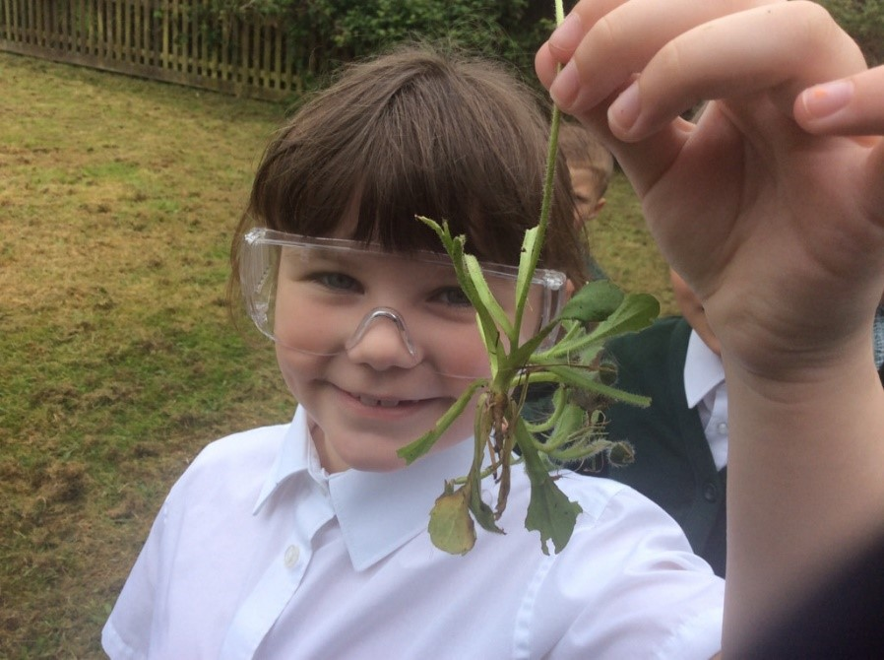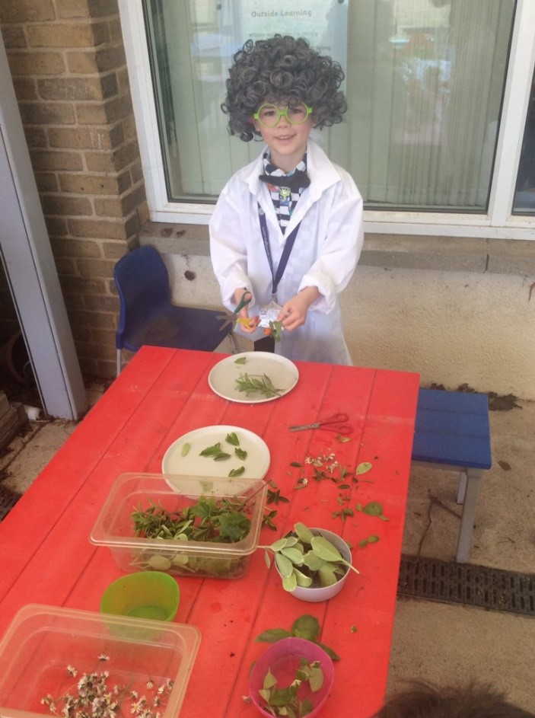
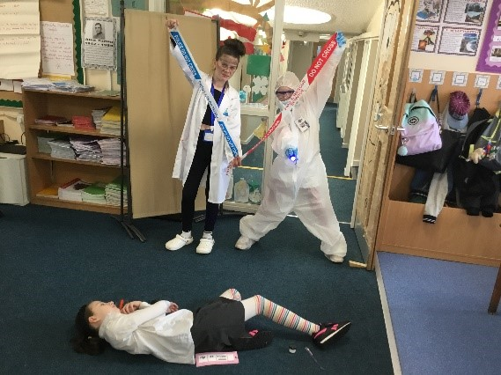



John Bunyan Nursery
We are now allocating places for September in our Nursery.
We offer both 15 and 30 hour funded places and take pupils from the age of 3.
If you are interested in a place, please contact the office asap.
If you know anyone who may be interested please ask them to contact us.
01376 321814

